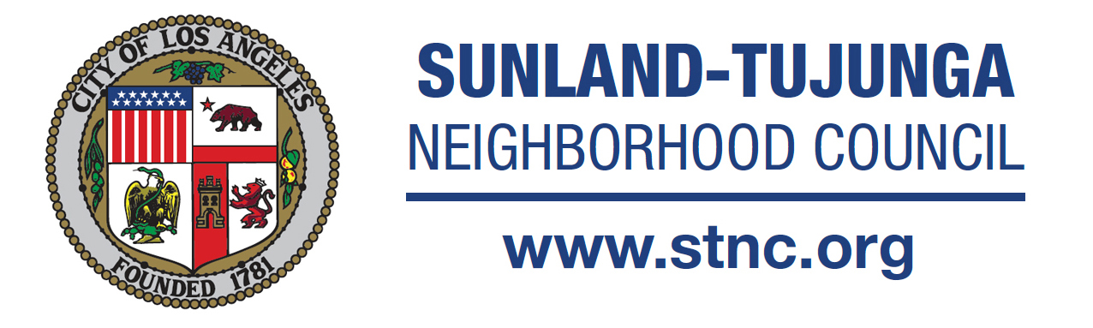
Committee Chair Joe DeCenzo
Committee Members Gerardo Barrientos, Debby Beck,
Lucy Berman, Krystee Clark (STNC Board Member),
Marcy Ferro, Lloyd Hitt, Marlene Hitt (STNC Board Member),
Allan Roman Reyes, Bill Skiles and Corey Stein

Share your voice and get involved: http://www.stnc.org
Stay informed with videos from the STNC Media Team: https://vimeo.com/stnc
Join our Great Streets Team: https://www.facebook.com/SunlandTujungaGreatStreets

Arts, Recreation & Culture Committee Meeting
Tuesday, August 2, 2016 @ 7:00 PM
Sunland Tujunga Chamber of Commerce Office
8250 Foothill Blvd., Ste. A, Sunland, CA 91040

MINUTES (Approved)

IN ATTENDANCE: Joe DeCenzo, Lucy Berman, Bill Skiles, Danielle Eubank, Corey Stein

Gerardo Barrientos, Lloyd Hitt, Marlene Hitt

1. CALL TO ORDER: Meeting was convened at 7:02 p.m. by committee chair, Joe DeCenzo

The Minutes of July 7th were reviewed and approved unanimously

without correction.

2. PUBLIC COMMENTS: for non-agenda items. No Public comments were presented at the meeting
3. DISCUSS/ ACTION: Dismissal of Committee Member Marcy Ferro The issue of committee member Marcy Ferro was discussed among the group. Her absence at four prior meetings and non- communication with any group members prompted the dismissal vote. RESULT: 7 in favor of dismissal, 1 abstain.
4. DISCUSS / ACTION: DCA Arts Activation Fund Grants
Each winning project is eligible to receive as much as $15,000. The program is designed to fund a range of projects across the City that complement the unique character of their neighborhoods. http://dcaredesign.org/artsactivate/apply Krystee Clark with Melissa Reischman to update; Allan R. Reyes to contribute No one associated with this agenda item was present at this evenings meeting. Item is tabled until further notice.
5. DISCUSS / ACTION: Mural to commemorate Historical landmark #1039 TCDS
Joe DeCenzo and Lloyd Hitt to update Joe DeCenzo announced that Pastor Daniel (the presumed owner of the property has not returned any messages. Lloyd Hitt updated the committee on progress of the traveling historical exhibit e.g. proposed dates and locations of installations and graphic themes. Further updates to follow.
6. DISCUSS / ACTION: Calendar project featuring local artists.
Krystee Clark and Gerardo Barrientos update No Updates available. Gerardo will notify committee when work on the project resumes.
7. Discuss/ Update: River Rock Arts Colony show at Back Door Bakery. Update by Debby Beck. “Open Studios” update from Melissa Reischman (if present) No one associated with this agenda item was present. Committee discussed the “Open Studios” event as a group. They confirmed the social media and on-line map for the artists presenting. Discussion regarding preparation and promotion for the participants also followed.
Further Discussion:
Open Updates by Committee Chair : Joe DeCenzo included “Burgers, Beer & Blues” event at McGroarty Arts Center. August 27, 2016 at 6:00 pm
Networking With Surrounding Neighborhood Councils
Developing CARD Comunity Arts Resource Directory, a publication or blog aimed at identifying artists, venues and events. Marlene Hitt will deliver preliminary data to Joe DeCenzo to begin compiling a database of relevant arts information and resources in the Sunland Tujunga area.

Meeting Adjourned at 8:03 p.m. and all were encouraged to attend National Night Out at Bolton Hall.

